Table of Contents
- Analysis
  - The project
  - Research
    - Maze generation algorithms
      - Randomized depth-first search
      - Randomized Kruskal’s algorithm
      - Randomized Prim’s algorithm
      - Eller’s algorithm
      - Growing tree algorithm
      - Conclusion
  - Pathfinding algorithms
  - Similar projects
    - Pac-Man
    - Bomberman
  - Project implementation
    - Framework
    - 2D vs 3D
  - Final decisions
  - Objectives
- Documented design
  - Implementation plan
  - Iterative development
    - Text-based prototype
    - Integrating Pygame into the project
    - Utilizing sprites and sprite groups
    - Implementing the character and collisions
    - Implementing the camera and optimizing the game
    - Implementing the map and tile colouring
    - Implementing items, item generation, and their usability
    - Implementing the timer, score system, and item counter as part of a new class
    - Change in plan
    - Implementing the enemy
    - Implementing the main menu and the foundation for other menus
    - Difficulty options
    - Pause menu
    - High score system not implemented
    - Final class diagram
- Technical solution
- Testing
- Evaluation
- Appendix
  - Code
  - Sources and other links

Analysis

The project
My idea is to create a videogame centred around solving randomly generated mazes with a controllable character and an enemy that tries to catch the character inside of the maze. The objective of this game will be to traverse the maze while avoiding the enemy and doing so under a time limit, while also achieving a high score.

Research

Maze generation algorithms
A maze can be represented as an acyclic, undirected, connected graph (or a tree) with cells being the vertices and paths being the edges, which means that algorithms which apply to graphs can be applied to generate (or solve) mazes. A maze such as this is called a “perfect maze”, in the sense that there is only one path between any two points in the maze. The algorithms can be modified to add the possibility of creating cycles in the graph (or loops in the maze), which makes the maze imperfect.
Before diving into the algorithms, I also want to explain a difference between what I call “Grid-based” and “Tile-based” representations of mazes, and which one I think is more suitable for my game. There are many more possible representations, but I want to narrow it down to these two as I feel like they’re the most suitable aesthetically.
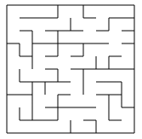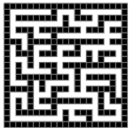
Grid-based and Tile-based representations respectively.
As can be seen on the images, both mazes are the exact same structurally but not visually. The former is better thought of as a grid of cells with 4 walls surrounding each cell while the latter as a grid of tiles with each tile either being empty or a wall. There is also a method to convert between them.
But it should be noted that the tile-based representation can house two types of mazes, one that can be converted to grid-based and one that cannot. Simply put, to be able to convert from tile-based to grid-based a certain structure must be kept: The maze must have an odd number of horizontal and vertical tiles (any maze converted from grid-based to tile-based will fulfil that), and each tile on the odd rows and columns must be cells (if counting starts from 0). The tiles between two cells (only the ones that touch them face to face and not corner to corner) are walls that will be carved to produce passages. If this structure is not kept, then mazes will end up looking like this:
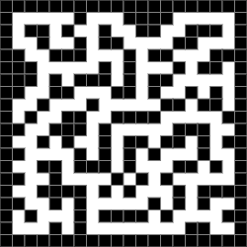
Which is fine if such a representation is desired, but it often leaves clusters of inaccessible walls and cells. I want to keep a more robust and less wasteful structure which makes this undesirable.
It should also be noted that it’s possible to change the ratio of the thickness of the walls to the thickness of the passages in the tile-based representation which could be utilized in the game for aesthetic purposes.
Now, back to the algorithms. They vary in implementation, computing speed, complexity, and biases, and I will be comparing them based on these points.

- Randomized depth-first search
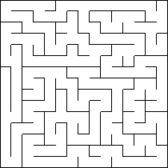
Also known as a “recursive backtracker”, this algorithm can either be implemented recursively or iteratively, preferably iteratively as otherwise maximum recursion could be reached which would lead to an error. However, the maze must be exceptionally large for that to happen, so for most uses the recursive version should be fine.
What it does is, after choosing any point in the maze (which could be chosen at random), it marks it as visited, chooses an unvisited cell next to it, carves a path to it, and invokes the routine on the chosen cell. Once there are no more unvisited neighbours it backtracks until it finds such a cell.
Pseudocode (recursive approach):
Given the current cell as a parameter
Mark current cell as visited
While the current cell has unvisited neighbours:
Choose one of the unvisited neighbours
Remove the wall between the current cell and the chosen cell
Invoke the routine for the chosen cell
It is fairly straightforward to implement, but as mentioned earlier the recursion might become a problem. In the worst case, every cell could be pushed to the call stack, possibly resulting in overflow.
Pseudocode (iterative approach):
Given the current cell as a parameter
Mark it as visited
Push it to the stack
While the stack is not empty:
Pop a cell from the stack
Make that cell the current cell
If the current cell has any unvisited neighbours:
Push the current cell to the stack
Choose one of the unvisited neighbours
Remove the wall between the current cell and the chosen cell
Mark the chosen cell as visited
Push it to the stack
This version utilizes an iterative approach instead of a recursive approach, which means there’s no danger of overflow and much larger mazes could be generated as a result. However, there’s still the possibility of every cell being stored in memory. A “bonus” of this version is that by storing backtracking information in the maze, the solution could be displayed from any point, which could be utilized in the game.
It should be noted though that this algorithm has a bias; since it’s depth-first, it tries to explore as far as it can before backtracking which makes it prone to generating long winding corridors with very little branching.

- Randomized Kruskal's algorithm
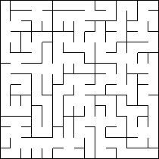
This algorithm (unrandomized) produces a minimum spanning tree from a weighted graph. It sorts all the edges from low to high, then takes the edge with the lowest weight and adds it to the tree, connecting vertices. If it creates a cycle, then the edge is rejected. This is repeated until there are no more edges left. The randomized version removes the sorting step and simply picks the edges at random.
Pseudocode:
Assign each cell to a separate set
Create a list of all walls
Randomize the list
For each wall in the list:
If the cells divided by this wall belong to different sets:
Remove the wall
Join the sets of the cells
This algorithm is biased to generate mazes with many short branches. The fact that it is easy to solve is both a pro and a con as it could be used for easier levels in the game, but the same could be achieved by making a smaller maze using a less biased algorithm.

- Randomized Prim's algorithm
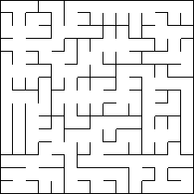
This algorithm is very similar to Kruskal’s algorithm in that they’re both used to produce minimum spanning trees and that they both have the same bias of lots of short paths. Starting from a random cell, it selects walls around that cell and adds them to a list, then randomly removes the walls while avoiding loops, adding each new adjacent wall to the list.
Pseudocode:
Pick any cell in the maze
Mark it as part of the maze
Add the walls around that cell to a list
While the list is not empty:
Pick a wall randomly from the list
If only one of the cells adjacent to that wall had been visited:
Remove the wall
Mark the unvisited cell as part of the maze
Add the walls around that cell to the list
Remove the wall from the list
It’s very fast, and at most won’t hold more than a fraction of the maze in memory. It can be considered a better alternative to Kruskal’s.

- Eller’s algorithm
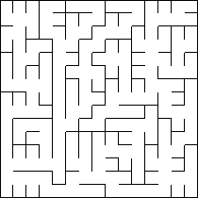
First, it creates a row of cells, each belonging to a different set. Then it carves the walls between them randomly and combines their sets, but only if they belong to different sets (If two cells belong to the same set then there is a path between them, so connecting them means creating a loop). After this, it randomly creates downwards connections with at least one connection per set, then it fills the spaces between them and repeats the procedure on the newly made row, eliminating any need to check the previous row. This can be repeated an unlimited number of times until the last row where the chance of joining cells becomes 100%, still without joining cells from the same set.
Pseudocode:
Create a row of cells
Put each cell into its own set
For each cell in the row:
If two adjacent cells belong to different sets:
Randomly carve the wall between them and combine their sets
For each set:
Randomly carve the wall below them joining the cells and combining their sets,
with at least one downward connection per set
Fill any empty cells and repeat the steps until the last row is reached
For the last row, carve the wall between different sets with a 100% chance
This algorithm excels in many things. It only ever looks at a single row when generating a maze which makes it very fast and memory light, and it’s quite unbiased when compared to the algorithms discussed previously - it has a nice balance between long passages and short dead-ends (it does tend to make the final row a single long corridor though). Since it only ever looks at one row at a time, it could be used to generate infinitely tall/wide mazes (it would only extend in one direction infinitely), which might be applied to create a separate gamemode. For example, a gamemode where you must explore as far as you can before the timer runs out, or a gamemode where you see how far you can explore an unlimited maze with unlimited time.

- Growing tree algorithm
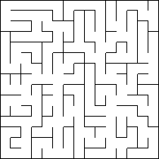
Newest/Random, 50/50 chance
Firstly, an empty list that will hold cells is created, then a cell is added to it randomly. Next, a cell is chosen from the list and a path is created to any unvisited neighbouring cell, adding that cell to the list as well. If a cell has no unvisited neighbours, then it is removed from the list.
Pseudocode:
Create an empty list
Add a random cell to the list
While the list is not empty:
Pick a cell from the list
If the cell has any unvisited neighbours:
Carve a path to any of them
Add that cell to the list
Else:
Remove the cell from the list
This algorithm is interesting in how customizable it is, which comes from modifying step 4. The mazes vary drastically based on how a cell is picked from the list. For example, picking the newest cell will replicate the behaviour of the Recursive Backtracker, while picking the cells randomly replicates the behaviour of Prim’s Algorithm. There is lots of room for experimentation as you can use two behaviours at once and split the chance of choosing either one (or change the chance to be biased towards one method), or even introduce other methods like picking the oldest cell.
Regarding complexity, in the worst case it can hold the whole maze in memory, but that’s unlikely (as is the case with most of these algorithms).

- Conclusion on maze generation algorithms
Overall, there are plenty of algorithms to choose from, all with their own pros and cons. I think the best time to decide on which algorithm to use in my game would be after testing them, so the final decision is left for later.

Pathfinding algorithms
Between Dijkstra’s and A*, the latter is the more appropriate choice for my use case. Not only would Dijkstra’s algorithm compute a lot of unneeded paths, but it would also not use heuristic methods. A* on the other hand will provide a solution as quickly as possible, which in the case of a game is much more important than accuracy.

Similar projects
My idea is not unique, as mazes were quite a popular subject for many arcade games. There are many ways to make a game with mazes “fun”, for example by introducing enemy chases, time limits, scores, and obstacles. I will look at some projects that I find similar enough in nature to mine and try to find what made them popular, and what I can borrow from them.
- Pac-Man
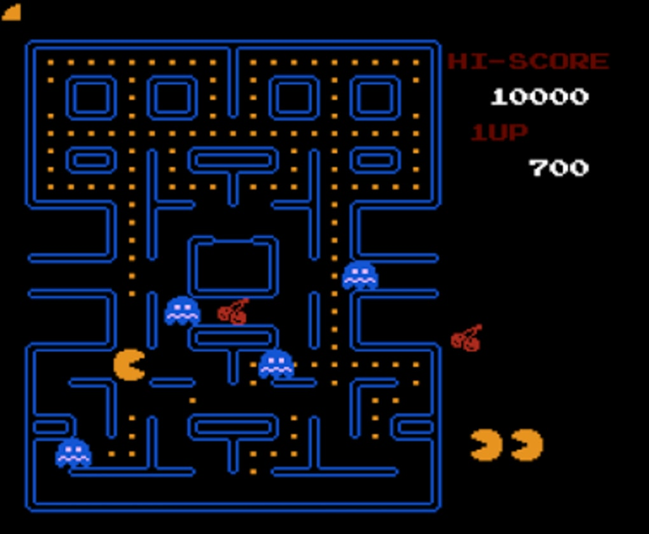
The idea for my game is very similar in concept to the classic game, Pac-Man.
The similarities are that they both have mazes, enemies, a controllable character, and a score system. Pac-Man's maze consists of many loops which allows for a degree of manoeuvrability in avoiding the four enemies that constantly follow him. The goal is to collect all pellets, but there are also other items that award points when eaten and power pellets that temporarily allow Pac-Man to eat the ghosts.
The goal of my game is not to explore the whole maze (or collect all pellets, which equates to the same thing), but to find the exit. There is also a time limit in my game, which further reinforces the fact that the player needs to find the exit as fast as possible, and not stay in the maze collecting all pellets. In my game, there is also only one enemy instead of many, and the mazes will be much bigger, which means that the enemy could be less of an obstacle.

- Bomberman
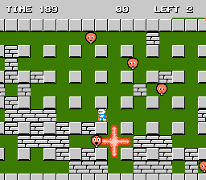
Bomberman is another classic game. However, in this game the maze is not the same as in my game or Pac-Man. It is almost entirely destructible, with the focus being on destroying the tiles and enemies using an infinite supply of bombs. Interestingly, the only tiles that can’t be destroyed are also the ones that need to be kept to preserve the logical structure of the maze.
A challenge occurs where you must be careful to not blow yourself up while clearing the path, as the bombs have a blast radius that can hit the player. What I find interesting is that in clearing the paths, the maze is almost created on the go. The progressive change of the maze could be something I borrow.
My game and this game have some similar factors, like a time limit, a controllable character, an enemy, and a maze
Project implementation
- Framework
The project will be implemented in python since I’m the most familiar with it, which leaves me with several free tools to pick from. I have no prior experience with any of them, so this will be my first time utilising them.

- Panda3D (https://www.panda3d.org/)
A framework for developing 3D games and applications.

- Ursina (https://www.ursinaengine.org/)
Built on Panda3D. This could be an alternative which is more convenient to use.

- Pygame (https://www.pygame.org/hifi.html)
A framework for developing 2D games and applications using SDL. This is the most popular and the most well documented python library for developing games.

- Two-dimensional or three-dimensional?
I think both 2D and 3D would be suitable for my game as they both have pros and cons, but I don’t think it will be feasible for me to develop a 3D game from scratch, so I will have to settle with 2D (Pygame).

Final decisions
Since the game will be 2D, the view on the maze will be from above, I.e., top-down. It is still possible to create a first-person game in 2D, but I don’t think it will fit the style of the game. The view will also be zoomed in close enough so that the whole maze is not visible at once. This is done so that it’s not possible to just trace the path from the entrance to the exit.
Another point to consider is the representation of the mazes I will use. I think the tile-based representation is the most suitable for my game. Although subjective, I think the thicker walls are more aesthetically appropriate for a game as opposed to the almost paper-thin walls of the grid-based representation. Also, with thicker walls comes the ability to draw on them, I.e., give them a texture. This is especially useful since I will need to create a way to distinguish an exit from a regular wall, as well as from an aesthetic point of view as I could modify more than just their colour if I wanted to.
Taking inspiration from Pac-Man's pellets, I thought it would be a good idea to make it so that there would be an indication of whether a player crossed a tile or not. Pac-Man's pellets act in this way naturally, since all the paths are filled with them and walking through them allows Pac-Man to automatically consume them, which shows whether that path has been crossed or not. In my game, a better alternative would be to automatically colour crossed paths (or use another effect), to indicate that they have been visited. Awarding points for said act is also a good idea, since this would reward the player in the case that they traversed a lot of paths while searching for the exit.
Bomberman and Pac-Man also have items/abilities that aid the player, which I like. In my game, items should make the experience a bit less monotonous. Therefore, I have thought of two items to aid the player: an item that can break a wall, and an item that lets the player jump over a wall. The player will start out with one of each, but more of them will be scattered across the maze. I’m not sure on how rare they will be yet. This, together with the colouring idea, should be good rewards for exploration of the maze. By having two items with similar functionality but different executions, the player could be subject to making some interesting decisions while exploring the maze or running from the enemy.
The time limit will be represented by a timer shown on the screen. It can go below zero.
The enemy will begin near the exit of the maze. As the timer decreases, the enemy becomes faster. After the timer reaches 0, the enemy will start to seek out the character at a speed higher than theirs and breaking through walls to create a direct path.
The possibility of making a maze with loops was discussed before. In my opinion, this will be more suitable for my game as in case the player gets cornered by the enemy, they will have a chance to avoid it. Another thing that it provides is the possibility of different solutions, which is more interesting than a one path solution.
The character will have a map that will draw out the maze as it is being traversed, this gives the player some idea as to where they are relative to the whole maze and helps them with navigation. The enemy can be seen on the map only if it is currently in a discovered part of the maze. This will also give an advantage in the case that the player explored a lot of paths while searching for the exit, as more paths explored means more chances to spot the enemy before you’re in danger.
There will be a score system. Points will be given when the player explores a new tile, and when the player picks up an item. Points will be lost for every second that passes when the timer is above zero.
The player will be given the choice of playing under one of three difficulties: easy, medium, and hard. Each time a new game is started, a new maze of the chosen difficulty will be generated. The difficulty of the mazes will depend on factors such as the size of the maze, the time limit, the behaviour of the enemy, and the scarcity of the items. There will be different ranks depending on the score (A, B, C, …). The high score, best time, and rank associated with each difficulty will be saved and displayed.

Sources:
See appendix.

Objectives
MUST HAVES
- Tile based map on which the maze will be generated
- An algorithm that generates a random maze on the map
  - Must have modifiable parameters, like
    - Width
    - Height
    - Chance to generate loops
  - Must be solvable
- A character to control in the maze
  - Pressing the UP key moves the character upwards
  - Pressing the DOWN key moves the character downwards
  - Pressing the RIGHT key moves the characters to the right
  - Pressing the LEFT key moves the characters to the left
  - Pressing a combination of keys moves the character appropriately
  - Each time the character crosses a tile, it gets coloured
- Camera
  - Camera centred on the character
  - The camera is close enough to obscure the view of the whole maze
- A timer
  - Can be set different times
  - As a second passes, the timer decrements by one
  - It can go below zero
- A follower enemy
  - Pathfinding to navigate the maze
  - Has an aggression system
    - If it’s far away from the player, it just follows a random path
    - If it’s close, it starts following the player
  - When the enemy touches the character, the player loses
  - As time passes, the enemy gets faster
  - When time reaches 0, the enemy becomes very fast and breaks through walls on a direct path to the player
- A map
  - The maze gets drawn on the map as it is being traversed
  - The character’s position in the maze is seen on the map
  - The enemy can be seen on the map, but only when it is currently on an already discovered path
- Items
  - An item that lets you break a wall
  - An item that lets you jump over a wall
  - You start with one of each
  - You can find more in the maze
- Main menu
  - Allows to:
    - Start the game
    - See high scores
    - Close the game
- Pause menu
  - Allows to:
    - Resume the game
    - Quit to the main menu
- HUD
  - Shows:
    - The time
    - The score
    - Amount of items
- Score system
  - Gain points for:
    - Picking up items
    - Colouring tiles in the maze
  - Lose points for:
    - Time spent in the maze when the timer is above zero
  - Rank calculated based on score
- Three game difficulties
  - Easy
  - Medium
  - Hard
  - Can be played as many times as one wants
    - Each time a new game is started, a new maze is generated
  - High scores, and associated ranks and times are saved for each difficulty.

NICE TO HAVES (BUT NOT REQUIRED):
- More beautiful/advanced visuals

Documented design

Implementation plan
There are many possible ways of implementing mazes, and I have decided to use a two-dimensional array which will act as a tile-based grid on which the maze will be generated. A tile-based grid is commonly used as the basis of many 2D video games’ graphics system, and I think this system is the most suitable for my game as well. The tiles and the grid will be represented as objects using OOP, which will allow each separate tile to have their own properties, like coordinates, a visited status, or the type of the tile. This will prove to be very useful in a game since these data will need to be accessed by many procedures and functions and having it tied to the object will make it more convenient to access.
This also means that, when implementing the ability to destroy walls, it will be simple as I will be able to just change the wall object for a passage object.
Below is a basic class diagram which describes the relationship between the classes I plan to use. An arrow leading from class A to class B means that class A inherits from class B. A line starting at class A and ending in a dark circle at class B means that class B contains class A.
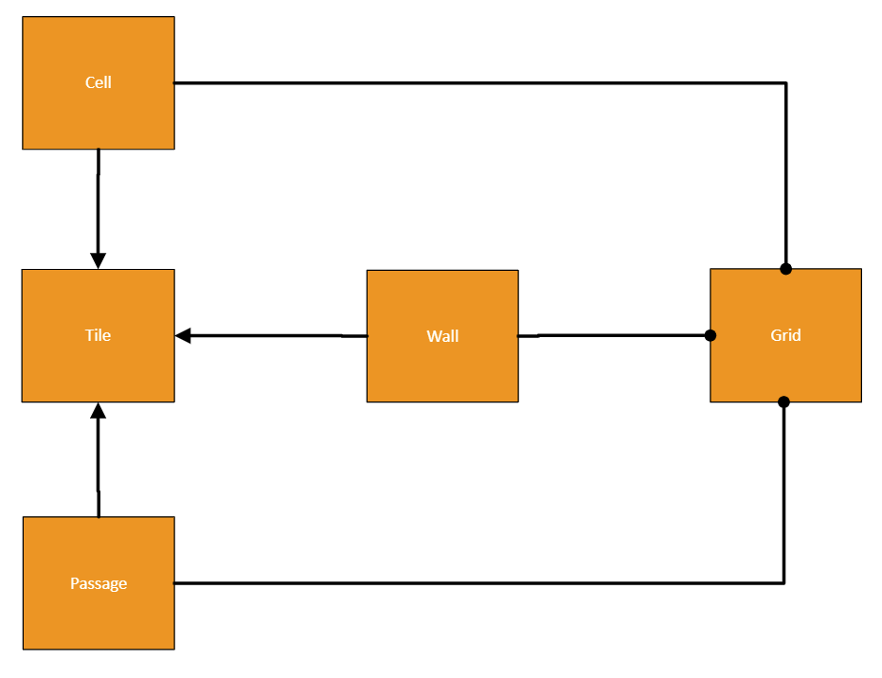
Grid is a class that contains a two-dimensional array which acts as the tile-based grid, which will be populated with three types of tiles. Tile is a basic class that will have some parameters and methods that can be shared by the three other classes inheriting from it (Wall, Cell, and Passage).
Wall is a tile that cannot be walked through, Cell is a tile that can be walked through, and Passage is a tile that is placed between two cells and can also be walked through. One might think then that it’s redundant to have both cells and passages which both serve the same purpose, however this separation is important. When using passages between cells, logically the maze becomes a graph, which allows different algorithms to be utilized. This was discussed at the start when distinguishing between the types of mazes. To repeat, the cells can be thought of as nodes, and the passages as edges.

Iterative development
In this section I will be writing code and constantly changing and adding to it, as well as explaining how it works.

- Text-based prototype
Firstly, I have created a prototype for the described classes, and I implemented a maze generation algorithm, namely the recursive backtracker, as a method of Grid. The prototype is currently able to generate a random maze using this algorithm with 3 variable parameters (number of horizontal cells, number of vertical cells, and the chance to generate loops) and print it in the terminal. Here is an example of a maze generated with my code:
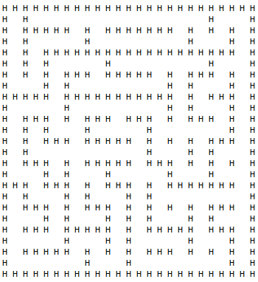
A 12x12 maze with a 10% loop chance
It works by iterating through the rows and columns of the maze using a nested for loop and printing the objects as characters, with the character printed depending on the class of the tile.
It should be specified that the number of cells is not the same as the number of tiles. Given 12x12 cells, the number of tiles used is 25x25.
Below is an updated class diagram that reflects my code.
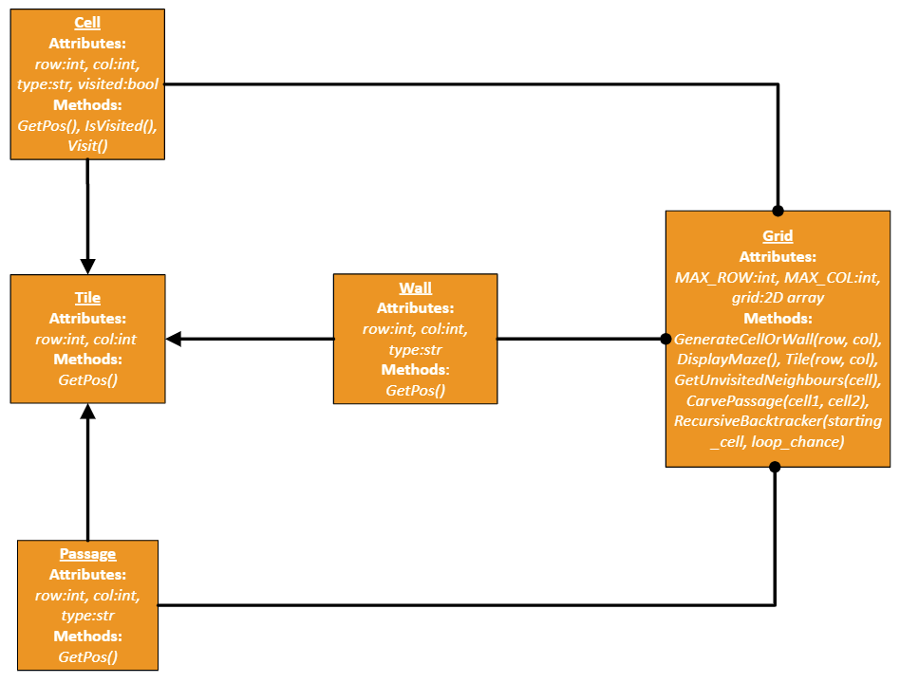
- Integrating Pygame into the project
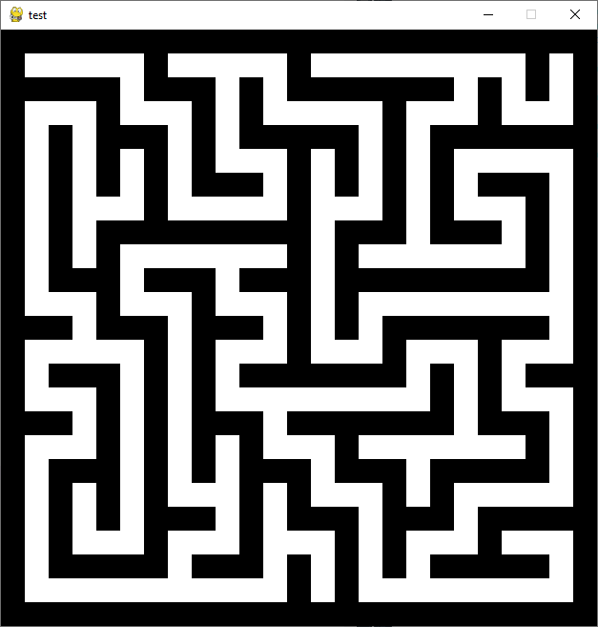
The next step is making it graphical, and for that I need Pygame. Since I don’t have any prior experience with it, I first created a small project using a tutorial and the official documentation to grasp the basics. I learnt about sprites, sprite groups, surfaces, display surfaces, blitting (drawing something onto a surface), rectangles, game loops, collisions, events, images, rendering text, and some other concepts. I will explain these concepts as they appear in my game.
First, I created a small method that allows me to draw the maze graphically, just as a prototype. It works in a similar way to the method that prints it in the terminal, except it draws coloured squares of the same size for each element instead of letters. In this step I also implemented a game loop, which is a while loop that runs once each frame at a set FPS (in my case, 60). The game loop allows the game to scan for events (user inputs or other events), and then react to them. It is essential for action games like the one I will create.
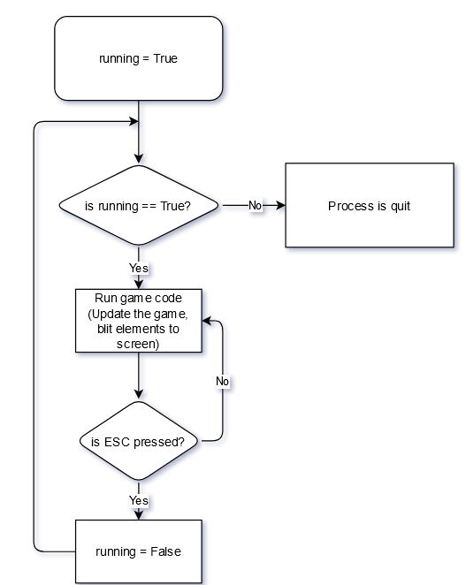
Current game loop flowchart
The next step is making the classes more flexible and applicable to a game.

- Utilizing sprites and sprite groups
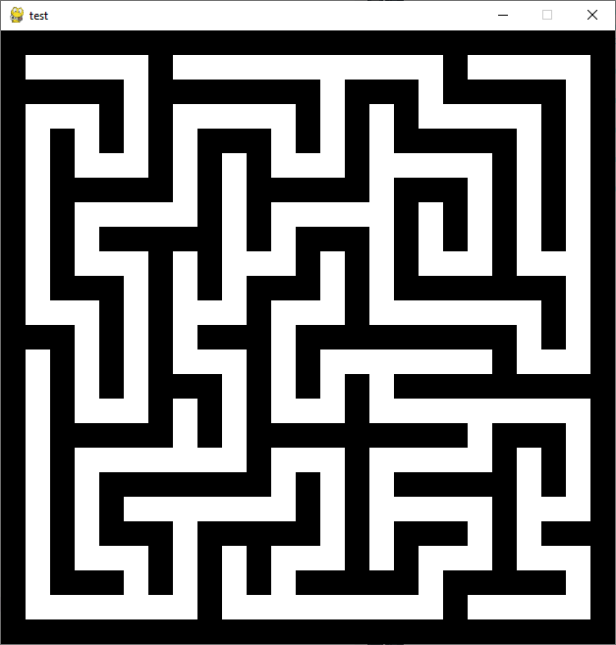
Right now, the maze you see on the screen is nothing more than rectangles drawn every pixel interval, while I need the maze to be separated into actual tiles with different properties and ways to interact with them. To implement that, I must convert the Tile class into a Pygame Sprite, or rather make it inherit from Sprite. This, along with sprite groups, will allow me to add important functionality to my classes. I will be able to add a surface property (the appearance of the sprite. It can be drawn during runtime or imported from an image), a rect property (a rectangle that can cover the same or a different area as the surface. It can be used to check for collision and coordinate management), and a hook method called “update” that can be overridden to produce any desirable effect. This method is especially useful with a Group object (the Group class allows for easy and quick storage and manipulation of different sprites. A sprite can belong to many groups); when called on a sprite group, it calls the update method on each of its sprites. This class also has a useful method called “draw” which blits all its sprites’ surfaces in the position of their respective rects. Together, these building blocks will allow me to create an interactable game.
Now, I changed the tile class to be a sprite. I also made separate sprite groups for every sprite type, like “TILES_GROUP”, “CELLS_GROUP”, etc., and made it so when a sprite object is initialized it is automatically added to the respective sprite groups. This will be true for every sprite I create in the future.
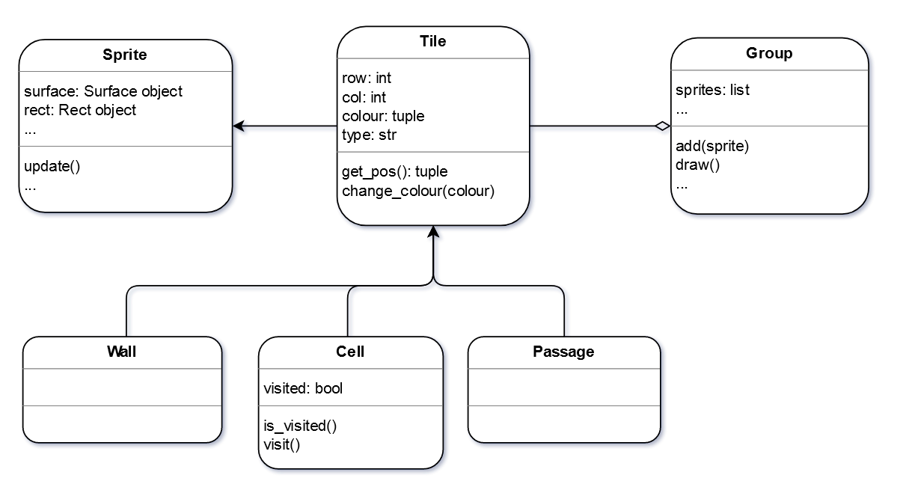
New Tile class
Next, I changed the method for drawing the maze. Instead of just drawing a coloured square based on the class of the tile it iterates through, it now accesses the surface and rect of the tile to get the appearance and coordinates respectively. However, since the initial position of any sprite is (0, 0), I also implemented a method that updates every tile’s position to be accurate. This method must be called every time the maze is updated. Now that the draw method is updated, the mazes generated still look the same, but this is a much better system because now I can easily access the properties of any tile I need. This is also very useful because each tile now has a respective rectangle that can be used to check for collisions. Next, I will implement a character to control in the maze.

- Implementing the character and collisions
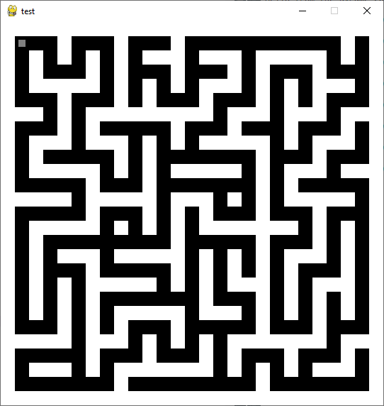
The character is the grey square in the top left corner. I also inverted the colours of the maze because I liked it more aesthetically.
The biggest hurdle in implementing a controllable character is the collision system. From my previous project I learnt how to implement a character as a sprite, control it and draw it on the screen (as well as draw other moving objects). This is done using an update method on the player sprite each frame to which a list of pressed keys can be passed as a parameter. But the project didn’t have any solid obstacles or other objects that could stop the player’s movement, only a projectile that upon touching the player killed their sprite and ended the game, so this was something new for me. Initially I thought it would be as easy as writing “If player touches object, stop movement” - but I was quickly proved wrong. I went through a couple iterations of the collision system until I reached the best one.
Before, the only variable in control of the player’s speed was “speed” by which the x and y coordinates of the player’s rect were incremented or decremented based on the key pressed. This made it a bit hard to see which direction the player was moving in. Now, there are two new local variables in the update method of the player, “h_vel” (horizontal velocity) and “v_vel” (vertical velocity). First, it calculates the position of the rectangle of the player, and then checks if it intersects any wall rectangles to see if movement should be prevented or not. To not iterate through every wall in the maze every update, it only checks the walls in a list that the “spritecollide” function returns. This function returns a list of any sprites in a group with which a target sprite collided. If any walls are collided with, then instead of letting the player continue moving forward, the player rect’s position is changed to be next to the wall rect. With h_vel and v_vel it can be seen in which direction the player was moving, and therefore at which side of the wall to place the player. This is done once for both horizontal and vertical movement. This system works flawlessly.
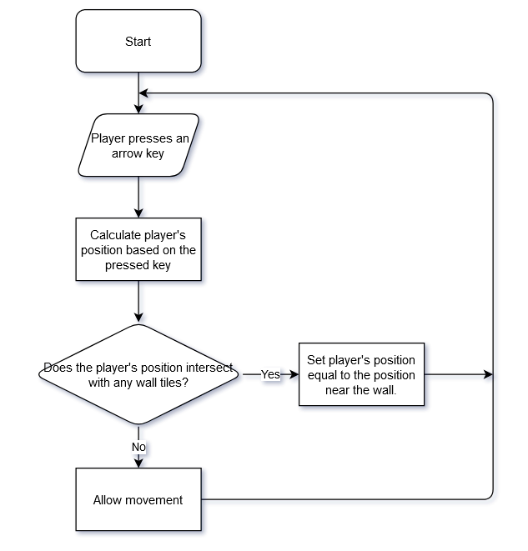
Simplified player movement logic
Next, I need to implement a camera.

- Implementing the camera and optimizing the game
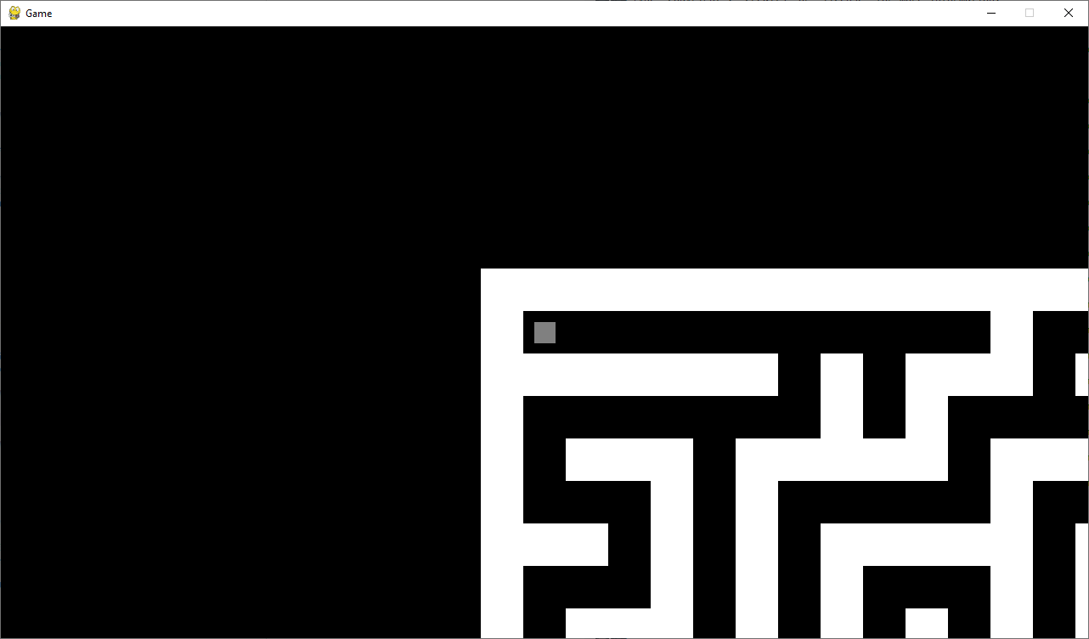
The resolution has been changed to 1280x720
At first, I had no idea how to approach this, but the key was in separating the real positions of the sprites and the position on which they will be drawn on screen. This is done by calculating an offset, and then subtracting it from the initial coordinates of every sprite during runtime when their surfaces are blitted. The offset, which has an x and y component, is calculated by subtracting half the screen size from the position of the centre of the sprite which you want centred. The way I implemented this is by first creating a custom sprite group class called Camera which inherits from Group, and then adding every sprite to this group upon initialisation. Next, I have overridden its draw method to produce the desired effect as described. I also made it so that the list of sprites in the group is sorted with the player first, so that the player’s sprite always appears on top of everything. Now there is a camera centred on the player that obscures the view of the whole maze. This also means that now there is no reason to blit every single sprite anymore, as you can only see a handful of them at a time. From my research, this is called “frustum culling” or “view culling”. I implemented this by making the visible screen’s coordinates into a rect and only rendering sprites if their rect intersects with this rect. This greatly improved performance. Next up I will implement the map and the colouring of the tiles.

- Implementing map and tile colouring
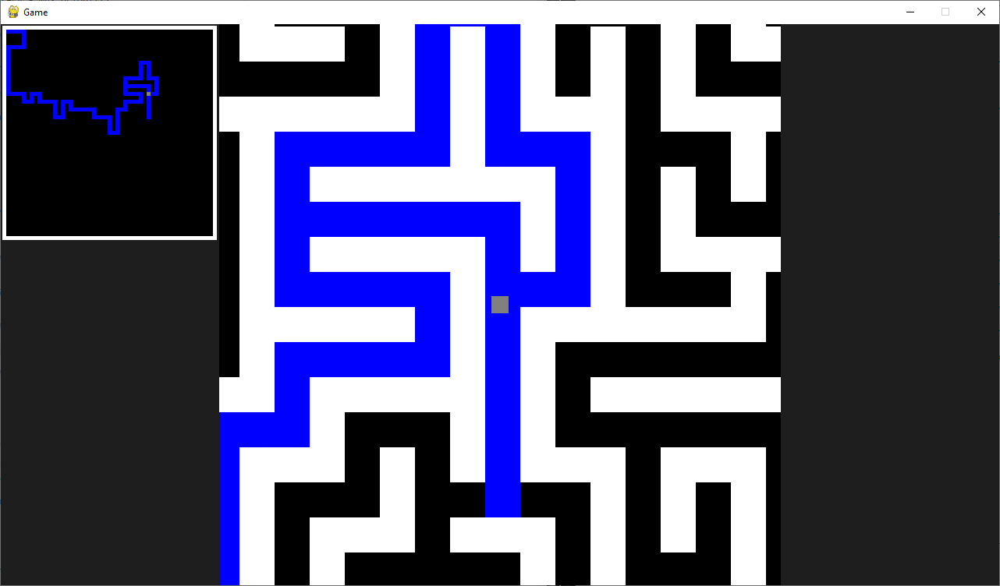
I also added borders to the sides of the screen.
First, I implemented the colouring system. It was quite simple – if the point at the centre of the player’s rect intersects with a tile’s rect, colour it a different colour (in my case, blue). This logic resides in the update method of the player. Next, I implemented the map as a method of Grid. It works just like the very first method that displayed the maze, except it doesn’t draw any walls apart from the outer ones and it shows the player’s position. It draws everything to a surface which is returned and can then be blitted on top of everything else. When drawing cells and passages, it uses their actual colour, which means that only cells that are coloured blue can be seen, since the default colour of a blank surface is black, and all the cells and passages are black as well. Now that the map successfully works, I will implement the items.

- Implementing items, item generation and their usability
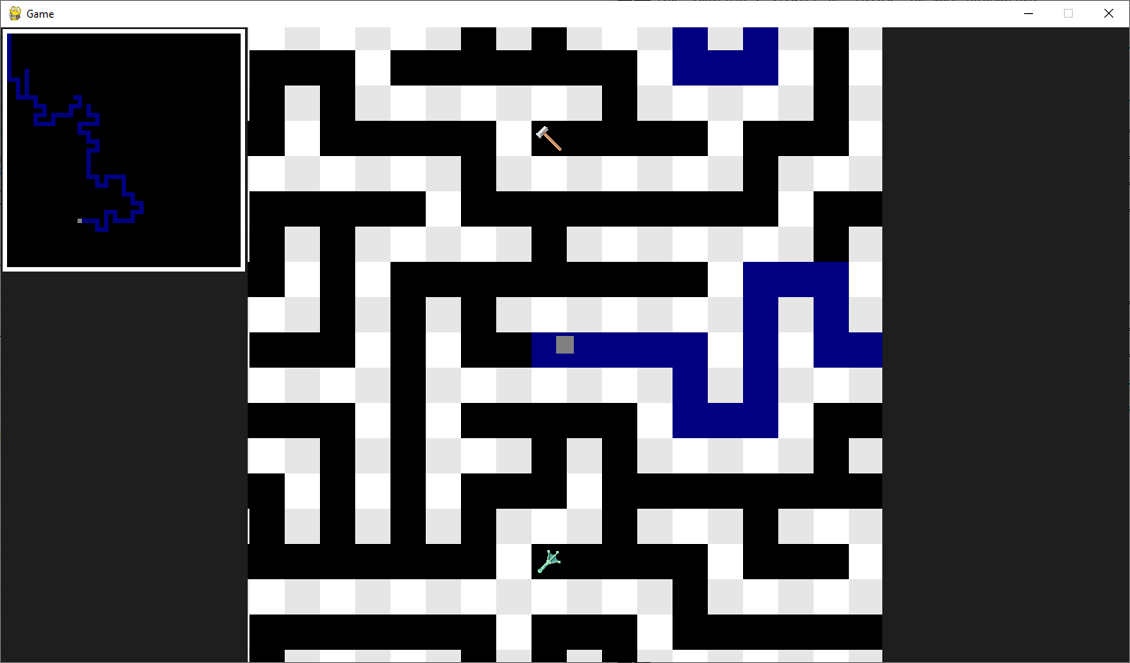
Made blue a bit darker to be easier on the eyes.
First, I have created an Item sprite. So far, everything in my game has been a solid-coloured square, so I want the items to stand out a bit. I have downloaded 2 free-to-use icons (see appendix) to use for this purpose. Next, I need the items to be generated in the maze. I want the items to only be generated in dead ends, so I have created a method in Grid to find dead ends and return a list of them, and then this list is passed to another method in Grid which generates the items with a customizable chance. Next, I made it so when the player touches an item, the sprite is killed and 1 is added to the player’s item counter for the respective item. This logic is intertwined into the update method of the player. The hardest thing was making the items usable. First, they need a condition that will decide if they can be used or not, and I decided to intertwine it into the update method of the player class as well, in the collision system to be exact. This means that the items can only be used when the player is moving against a wall and not standing still.
The items themselves work quite simply. The “BREAK” item replaces a wall tile to a passage tile (after which all tiles’ positions are updated using a method mentioned before), and the "JUMP” item moves the player to the other side of the wall, basically teleporting them. However, I discovered that the items cannot be used on every wall. Certain walls break the structure of the maze if removed, and these same walls are the only ones that can possibly make the player stuck after a jump, as they could be connected to more walls on the other side. These “special” walls are always on the positions where the row and column are both even, given that counting starts from zero, so I gave them a parameter that indicates that. I also made all the outer walls have this status (despite only half of them being on even rows and columns) so that the player cannot walk outside of the maze. Now that this status is programmed, I made it so the items can only be used if the wall is not special. Even after this, the jump item was bringing issues because it could be used when the player is partially in front of a special wall. To mitigate this, a check happens before the item is used that guarantees that the player stays in the bounds of the non-special walls.
And to make it easier for the player, I also made the special walls have a slightly different appearance. Apart from helping differentiate between the types of walls, it also makes the maze look a lot nicer. Next, I will implement the timer.

- Implementing the timer, score system, and item counter as a part of a new class
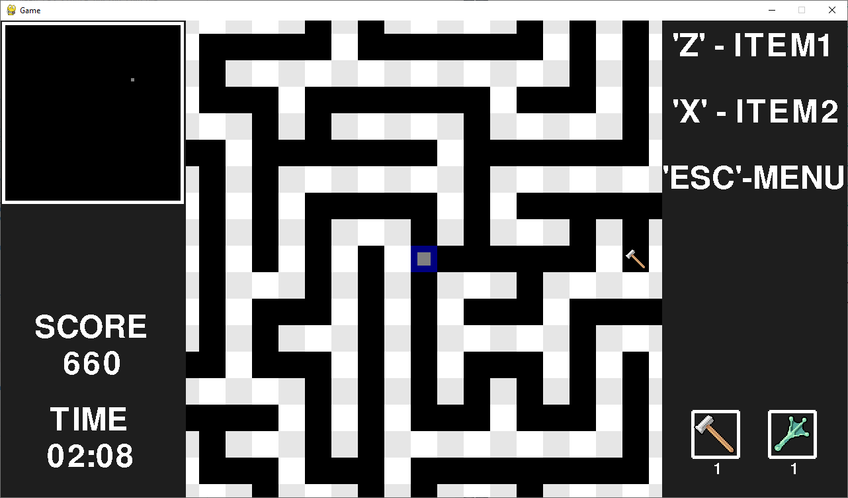
The player now spawns in a random cell every time.
I decided to implement the timer, score system, and item counter as a part of a new class called GameElements (I also added some info to the top-right to fill the empty space). I decided to take a modular approach and make every HUD element be displayed by a separate method, despite there being no use for only certain elements being displayed at a time. The class keeps track of the info like the time and the score and can display the different elements on the screen through methods which update and blit them on top of everything. The two borders seen before, as well as the map, are now also blitted using methods in this class. The implementation is not the most flexible as many of the elements’ positions are pre-set values.
The timer is stored in seconds and utilises Pygame’s event system to decrement each second by 1 (with the event system, you can make an event appear every set interval). There is a method that starts the timer so that it can be called at the right moment. I also wrote a method that converts the seconds into a “MM:SS” format and returns them. My initial idea was that when the timer reaches zero, it would continue decreasing and the enemy would start going on a direct path to the player, which would still give the player a chance to win if they're very close the exit and the enemy is far enough away. However, I decided to revert to the traditional system of “when the time ends, you lose”.
The score system works as intended. The player starts with a score equal to the total time in seconds multiplied by five, and then every 10 seconds the score is decremented by 50. The player gains 10 points every tile they colour, and 100 points every time they pick up an item. However, there are no ranks.
I also programmed a method that generates an exit in the maze as a part of Grid. The exit is a wall that’s painted black and will replace an outside wall upon generation, only if that the wall would normally be considered “non-special” (as otherwise, it could be behind another wall). The method picks a random wall from a list of available walls, which is returned by another new method.

- Change in plan
At this point to finish all my objectives I need to add: a main menu, 3 difficulty options, a high score system, a pause menu, and the enemy. But I am running out of time, so I will try to implement the most important thing first – the enemy. After implementing the enemy, if I have enough time, I will implement the other features.

- Implementing the enemy
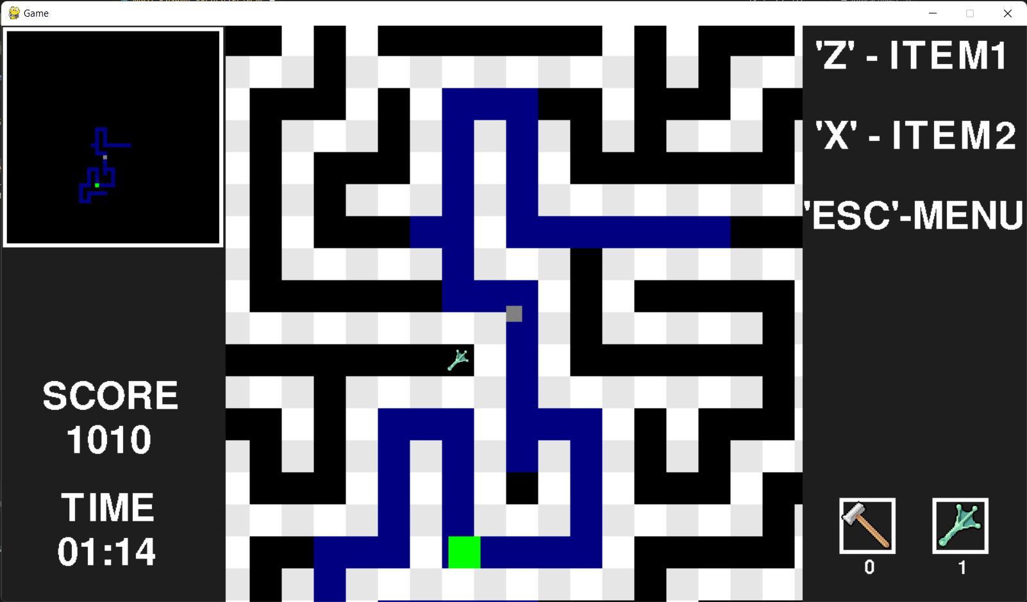
First, I have created a new Enemy sprite, and gave it the usual parameters like a surface, a rect, and speed, and added it to the appropriate groups. Next, it needed a pathfinding algorithm. I tried implementing the A* algorithm but was unsuccessful. Since I couldn’t spare more time, I used a pre-made module to provide the algorithm. The imported algorithm works only with a grid from its own module (which I named “path grid”, to differentiate it from Grid). So, I made a method in the Enemy class that can convert my grid to the path grid and store it inside of itself to compute paths between cells. The path grid mirrors the normal grid, but with the objects from its own module.
The next step was to implement enemy movement, as the module on its own only calculates the path from one tile to another. This was very tricky to implement, but to find the solution I had to look back at how the player’s movement is implemented. Initially I tried to use while loops to make the enemy move until it’s at its goal in one update, which obviously made it move instantaneously in the game. What I had to do instead is make it move only a certain amount every update, like the player.
To implement this, I added 3 new parameters to the enemy: the current path, the tile the enemy is currently on, and the tile it should move to next (these two tiles are always adjacent). The enemy always appears in front of the exit, and the path from that tile to the tile on which the player resides is calculated and stored to “path”. The next tile of the enemy becomes the second tile in the path (because the first tile is the starting tile). The direction of the next tile from the current tile is calculated (I.e., right, left, up, down) and then the enemy moves at its speed in that direction once per update until its centre intersects the tile’s centre. After that happens, the path to the player is recalculated and the cycle is repeated. This way, the enemy always follows the player on a fresh path and at a non-instant speed. The path could be refreshed less than once per update to increase performance, but in turn the enemy would start following the player’s old positions.
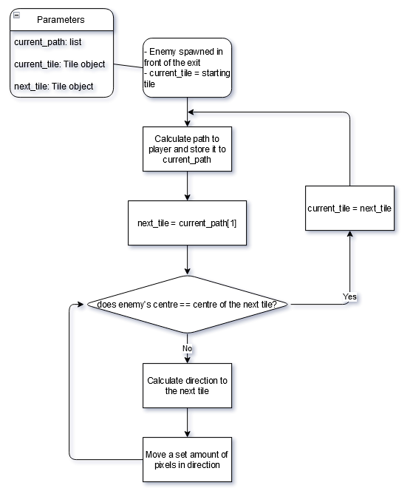
Enemy movement logic
I tried to implement the aggression and acceleration systems, but was unsuccessful, so the enemy now always moves towards the player and always at a constant speed.
The enemy’s display on the map was implemented by intertwining it into the “draw_map” method. It is only seen when it is on a coloured tile.

- Implementing the main menu and the foundation for other menus
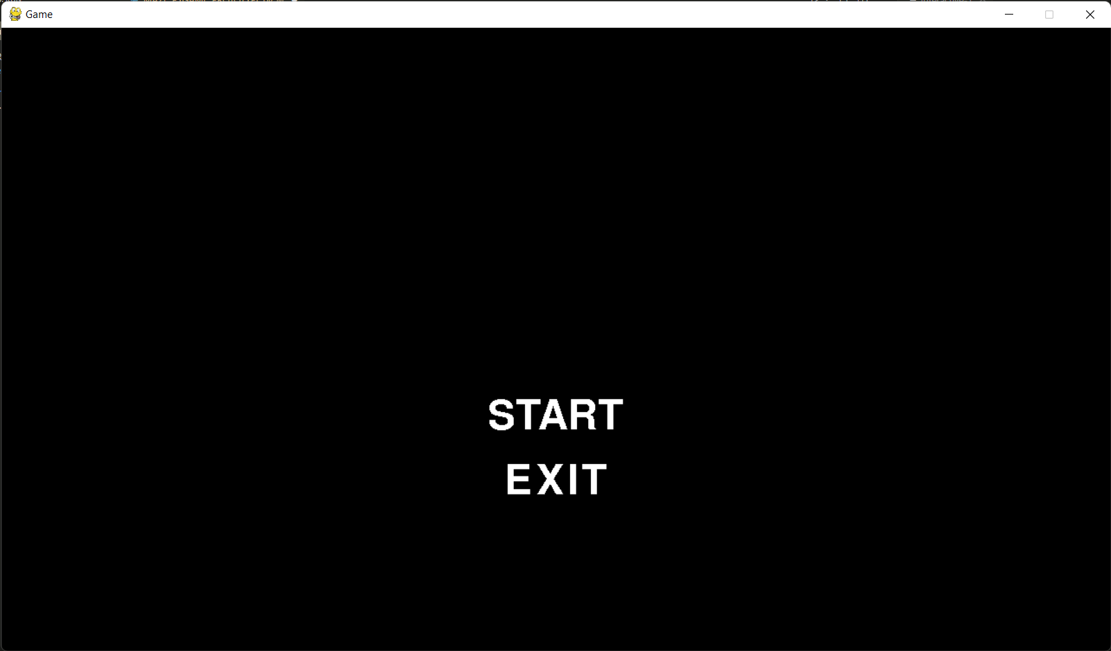
The main menu is now the first thing the player sees before any game variables or sprites are even initialized. I implemented it as a new method in the GameElements class, and it is navigated using the mouse, but the ESC key can be pressed to exit as well. To make switching between menus possible, I created new boolean parameters in the class which are used like switches (e.g., “main_menu = True”, “pause_menu = False”) to know when to show different menus. The methods return values based on what was clicked, so that it is possible to make a variable equal to the method’s output and then use conditional statements to react to any clicks by checking what value is held by the said variable.
I changed the game loop as well to allow different menus to work. Similarly to the system I just described, there are now new variables which are responsible for what code the game loop runs. For example, if “game_started” is true, the game loop goes through the code that initializes everything and starts the game, and then sets “game_started” to false. This part of the code is then ignored until “game_started” is set to true again. In this way, the 4 parts of the game loop (the main menu, the starting generation and initialization of the game, the game itself, and the pause menu) can switch each other on and off by changing the flags from False to True and vice versa.
This system is also handy because it is basically multiple game loops inside of one. This allows me to interpret inputs and events completely differently in each loop.

- Difficulty options
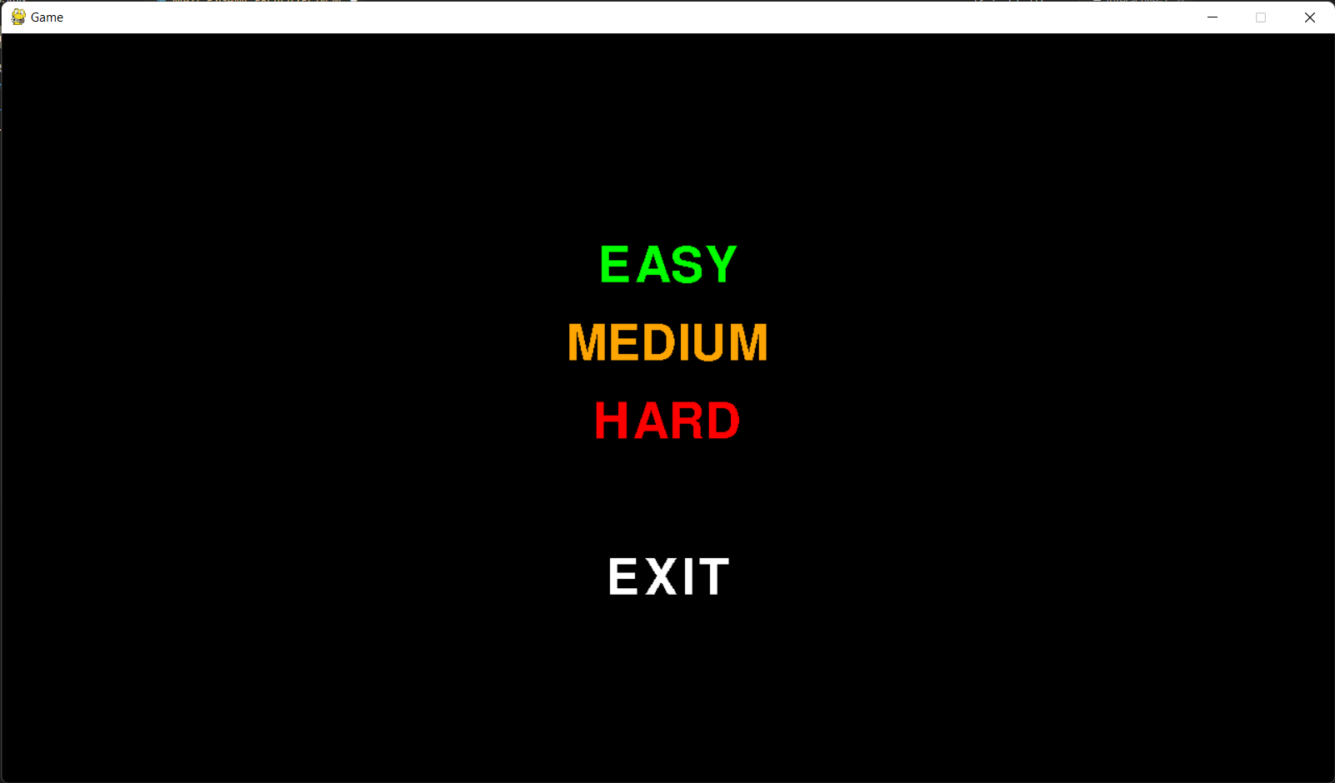
Now, when the player clicks on START, three difficulty options are displayed. This works and is implemented pretty much the same as the main menu. They are intertwined using flags so it’s possible to go from one to the other.
In the game loop, the variables returned by these clicks will determine what variables will be used in the generation of the game. “EASY” will create a small maze with a lot of items and loops, but little time. “HARD” will create a very large maze with less items and loops, and more time to complete the maze. “MEDIUM” creates a maze with a balanced experience.

- Pause menu
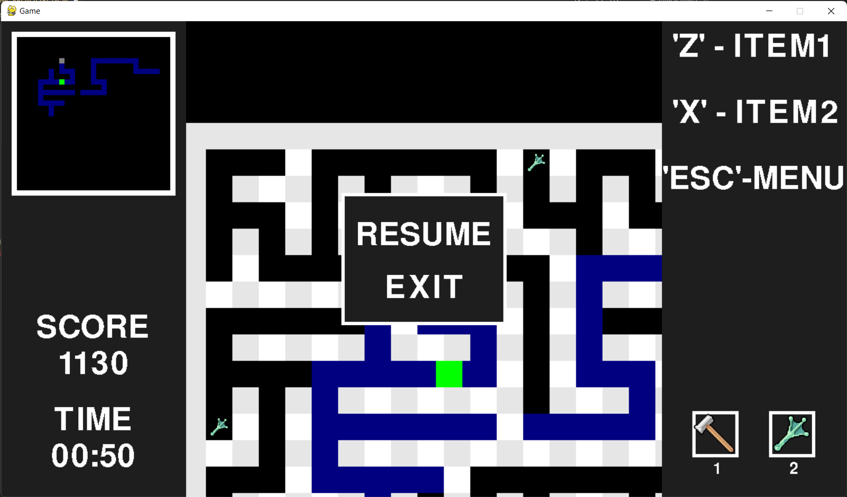
Again, the pause menu works extremely similarly to the other two menus. When the player presses ESC, this menu is displayed, and it stops the loop responsible for the game. Pressing ESC again or clicking resume resumes the game. Pressing EXIT returns the player to the main menu. I also made it so that reaching the exit or getting touched by the enemy sends you to the menu (previously, these actions closed the game).
When back at the menu, a weird issue occurred where when starting a new maze, the previous sprites didn’t seem to disappear and there appeared invisible wall tiles everywhere that stacked on top of each other. What happened, was that all the previous sprites kept existing and cluttering the game. To prevent this, in the loop responsible for maze generation it now simply removes all the sprites before starting a new game.

- High score system not implemented
The high score system was not implemented, as I decided to focus on improving the existing code and this report. With this, the implementation is finished.

- Final class diagram
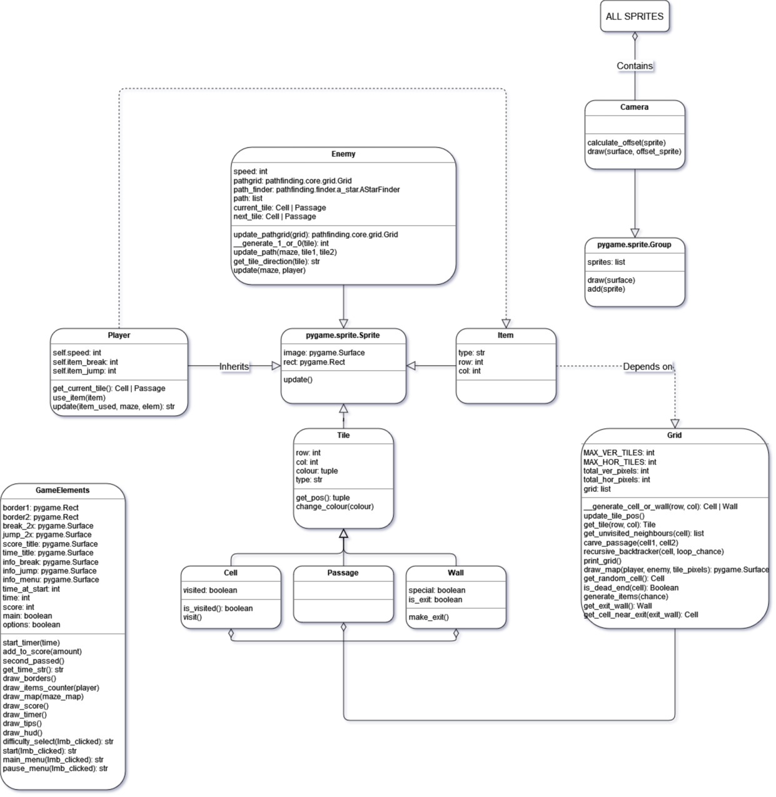

Technical solution
See appendix.

Testing
In this section I will comment on the completeness and provide evidence of the objectives I set.
Almost all the testing was done as part of the iterative process, so I will provide tests that showcase the finished game. It should also be mentioned that before starting development I didn’t have enough knowledge about pygame or game development to write completely exhaustive objectives.
Objective | Achieved | Evidence | Notes
1. Tile based map on which the maze is generated | Yes | See p. 15 – 16
2. An algorithm that generates a random maze on the map | Yes, but not perfectly | See p. 15 – 16 | I wanted to test more algorithms before making a final choice, but due to time constraints I had to settle with the recursive backtracker.
a. Must have modifiable parameters, like:  i. Width  ii. Height  iii. Chance to generate loops | Yes | See video Testing 2.a
b. Must be solvable | Yes, but not perfectly | See video Testing 2.b | As soon as the exit is touched, the game is considered finished. I feel like this could’ve been done better by being able to enter the exit instead of just touching a solid wall coloured black. A victory screen and a loss screen would improve the experience as well.
3. Controllable character  a. Movement keys work  b. Tiles get coloured | Yes | See video Testing 3 | I did not consider the collision system at the time of writing the objectives, but I provided evidence for it in the video nonetheless.
4. Camera  a. Centred on the character  b. Close enough to obscure the view of the whole maze | Yes | See video Testing 4 | The distance of the camera is not moved, but rather the size of the tiles are changed to make the view smaller or bigger.
5. Timer  a. Can be set different times  b. Decreases by 1 each second  c. Can go below zero | Partially | See video Testing 5 | -The timer system does not go below zero, instead the game ends when it reaches 0.
6. Enemy  a. Pathfinding to navigate the maze  b. Aggression system  c. When the enemy touches the player, the player loses  d. As time passes, the enemy gets faster  e. When time reaches zero, the enemy becomes very fast and breaks through walls on a direct path to the player | Partially and not perfectly | See video Testing 6 | -The A* algorithm was implemented via a library.  -The enemy always follows the player.  -The enemy has a static speed.  -When time reaches 0, the game ends, and so the last objective is not completed.
7. Map  a. The maze gets drawn as it is being traversed  b. The character’s position is seen on the map  c. The enemy can be seen when it’s on a coloured path | Yes, but not perfectly | Evidence is present in all videos. | The size of the map must have a value set manually when creating game modes (The fact that it can go out of bounds without intervention can be seen in Testing 2.a).
8. Items  a. Item that breaks walls  b. Item that lets you jump over walls  c. Start with one of each  d. Find more in the maze | Yes, but not perfectly | See video Testing 8 | The items work almost as intended except for a couple problems/oversights.  1. When you have more than one of an item, and it is used while walking into a corner, then two items get used at the same time (I start showing this at 0:48).  2. Lack of animation for the jump item makes it look like a bug, but it works as intended. (Unfortunately, I didn’t have time to make it look more aesthetically pleasing)  3. It can be seen from other videos (e.g., Testing 4) that the items have a static size and do not scale with tile size of tiles – this is an oversight and is not intended.
9. Main menu  a. Close the game  b. See high scores  c. Exit | Partially | See video Testing 9 | -The high score system was not implemented, and so cannot be viewed.  (The ability to close the game with the ESC key can be seen at 0:09)
10. Pause menu  a. Allows to resume  b. Allows to quit to menu | Yes | See video Testing 10 | (Ability to close window with ESC can be seen throughout the video)
11. HUD  a. Shows the time  b. Shows the score  c. Shows the item count | Yes | Evidence is present in all videos. | (While I didn’t have this in the objectives, I added some tips to fill the top-right gap)
12. Score system  a. Gain points for picking items up  b. Gain points for colouring tiles  c. Lose points for time spent when it is above zero  d. Rank calculated based on score | Partially | See video Testing 12 | -As the game now ends when time reaches 0, the last objective is implemented differently.  -The rank system is not implemented.  Evidence of score lowering every 10 seconds is shown at 0:10.
13. Three difficulties  a. Easy  b. Medium  c. Hard  d. Can be played as many times as one wants  e. Each time a new game is started, a new maze is generated  f. High score, time, and rank are saved and displayed near each difficulty | Partially and not perfectly | See video Testing 13 | -The high score and the rank systems were not implemented.  -The last objective is not completed.  -The hard difficulty has very bad performance due to the large size of the maze (can be seen at the end of the video).
Final test: Completing one maze on medium difficulty. | - | See video Playthrough | This isn’t meant to be a replacement for any tests I might’ve forgotten to complete, but rather just a showcase of the final product.

Evaluation
Overall, I think the final solution is a successful one. Almost all the objectives were completed, and the game is more than playable and even enjoyable, even though I approached the development with the thought that it doesn’t need to be fun.
If I were to do it again, I wouldn’t pick to make a video game for a programming project. There are far too many subjective factors at hand which halt development and make you think of relatively trivial details. But there is a good side to this that far outweighs anything negative. Experiencing the process of creating a game with this relatively low-level tool (compared to a game engine, at least) was very interesting and insightful, and through this project I learned many fundamental game development skills that could be transferred to any environment.
There are some glaring issues with the code that make me feel a bit frustrated because I don’t have enough time to make it better or rework it. For example, there is a lot of boilerplate code. Most notable cases, in my opinion, are in the update method of the player class and pretty much the whole game elements class. A lot of this repeating code stems from the fundamental problem that in many cases the game needs to check things 4 times – check each adjacent cell, check each adjacent wall, check each adjacent tile, check each side, etc. This needless repetition often made me think if it wouldn’t be better to have this data stored as a parameter of each tile, which would make it so much easier to access, but at that point I couldn’t risk changing the whole system. Another fundamental problem that fuelled repeated code was blitting surfaces to the screen. With a class like GameElements, which almost fully consists of creating and drawing surfaces, it is especially noticeable. I feel like it is a process that is verbose by nature, and I wonder if I could’ve automated it. Just to illustrate my point, for any piece of text on the screen I must: create a font (thankfully these are reusable), then render the text using this font and get the surface, and then blit it to a designated position on the screen. And if I want the position to change during runtime, then I must also get a rectangle of this surface and calculate new positions for it each frame. Doing this routine for every sprite, surface, and piece of text is certainly inelegant, and perhaps I could’ve avoided it somehow.
There are also several quick workarounds for some problems in my code, when the problem should’ve been fixed from the root. For example: after generating a maze, each wall tile gets duplicated to the top-left wall of the maze for a reason I haven’t exactly found. Instead of trying to fix the cause, I added some code that removes the duplicates after generation. Another example: Each tile’s position needs to be updated after placement, when ideally the system would allow to place them in the correct positions from the start. Yet another example from my code is the need to use “try except” blocks in some cases when checking for neighbouring tiles, as the tile checked could be out of range, or the tile checked might not be of the correct type, which can lead to errors. It is possible to know in advance whether checking a tile in that position can cause an error or not, but the “try except” solution was the quickest.
One more thing that I think I could change is the fact that there is so much iteration happening each frame. There are glimpses of iteration through every tile, wall, or cell pretty much everywhere in the code, and I am certain it hurts the performance. I am not sure of a potential fix for this. How else can you check what intersects with what, for example, without comparing the coordinates of almost every tile? The only idea that comes to my mind is perhaps separating the map into quadrants, and only considering the tiles in the quadrant in which the player currently is, but I am not sure how feasible or logical that is. I have seen other games use chunks, which sound similar in theory, but I do not know how they work exactly.
All in all, there are many things I would like to work on and improve, but that doesn’t mean that I am not happy with the solution. It took me many days to get it into the condition that it is in.

Appendix
The code
- Declaring constants, p. 35 – 37
- Classes, p. 37 – 62
  - Tiles, p. 37 – 38
  - Grid, p. 38 – 45
  - Player, p. 45 – 50
  - Camera, p. 50 – 51
  - Item, p. 51 – 52
  - GameElements, p. 52 – 58
  - Enemy, p. 58 – 61
- Game code, p. 62 – 68

import pygame
from random import choice, random, randrange
from pathfinding.finder.a_star import AStarFinder
from pathfinding.core.grid import Grid as PathGrid
from sys import exit

pygame.init()

## DECLARING GLOBAL CONSTANTS/VARIABLES
# Max resolution.
MAX_WIDTH = 1280
MAX_HEIGHT = 720

# Commonly used RGB values.
WHITE = (255, 255, 255)
BLACK = (0, 0, 0)
GREY = (128, 128, 128)
LIGHT_GREY = (230, 230, 230)
DARK_GREY = (30, 30, 30)
BLUE = (0, 0, 128)
BRIGHT_GREEN = (0, 255, 0)
# Fonts that will be used to render text.
SMALL_FONT = pygame.font.SysFont(None, 35)
BIG_FONT = pygame.font.SysFont(None, 70)
# Custom event.
TIMER_EVENT = pygame.USEREVENT + 1

# Sprite groups.
TILES_GROUP = pygame.sprite.Group()
WALLS_GROUP = pygame.sprite.Group()
CELLS_GROUP = pygame.sprite.Group()
PASSAGES_GROUP = pygame.sprite.Group()
ENEMY_GROUP = pygame.sprite.Group()
ITEMS_GROUP = pygame.sprite.Group()
PLAYER_GROUP = pygame.sprite.Group()

# The size, in pixels, of a side of each individual square tile. Many other
# variables will depend on it.
TILE_PIXELS = 40

# Creating the window.
display_surface = pygame.display.set_mode((MAX_WIDTH, MAX_HEIGHT))
pygame.display.set_caption("Game")

# The two item textures are pre-loaded.
BREAK_TEXTURE = pygame.image.load("textures/W_Mace003.png").convert_alpha()
JUMP_TEXTURE = pygame.image.load("textures/I_FrogLeg.png").convert_alpha()

## CLASSES
# Sprite that acts as a row/column coordinate on the grid.
# Only needed for the other tiles to inherit from, will never be placed on the
# grid.
class Tile(pygame.sprite.Sprite):
def __init__(self, row, col):
super().__init__()
self.row = row
self.col = col
self.image = pygame.Surface((TILE_PIXELS, TILE_PIXELS)).convert()
self.rect = self.image.get_rect()
self.colour = None
self.type = None
TILES_GROUP.add(self)
CAMERA_GROUP.add(self)

def get_pos(self):
return self.row, self.col
def change_colour(self, colour):
self.colour = colour
self.image.fill(self.colour)

class Wall(Tile):
def __init__(self, row, col, is_special):
super().__init__(row, col)
self.type = "WALL"
self.special = is_special
self.is_exit = False
if self.special:
self.colour = LIGHT_GREY
else:
self.colour = WHITE
self.image.fill(self.colour)
WALLS_GROUP.add(self)

# Changes the wall to an exit.
def make_exit(self):
self.is_exit = True
self.change_colour(BLACK)

class Cell(Tile):
def __init__(self, row, col):
super().__init__(row, col)
self.type = "CELL"
self.visited = False
self.change_colour(BLACK)
CELLS_GROUP.add(self)

def is_visited(self):
return self.visited

def visit(self):
self.visited = True

class Passage(Tile):
def __init__(self, row, col):
super().__init__(row, col)
self.type = "PASSAGE"
self.change_colour(BLACK)
PASSAGES_GROUP.add(self)

class Grid():
def __init__(self, vertical_cells, horizontal_cells):
self.MAX_VER_TILES = vertical_cells*2+1
self.MAX_HOR_TILES = horizontal_cells*2+1
# Total pixels that the grid will take up.
self.total_ver_pixels = self.MAX_VER_TILES*TILE_PIXELS
self.total_hor_pixels = self.MAX_HOR_TILES*TILE_PIXELS
# Initialize a grid of walls, cells, and passages.
self.grid = [[self.__generate_cell_or_wall(row, col) for col in range(0, self.MAX_HOR_TILES)] for row in range(0, self.MAX_VER_TILES)]

# Given coordinates, returns the correct tile to be placed.
def __generate_cell_or_wall(self, row, col):
if row % 2 != 0 and col % 2 != 0:
return Cell(row, col)
else:
if row % 2 == 0 and col % 2 == 0:
return Wall(row, col, True)
elif row == 0 or col == 0 or row == self.MAX_VER_TILES-1 or col == self.MAX_HOR_TILES-1:
return Wall(row, col, True)
else:
return Wall(row, col, False)
# Update's the tiles' positions, as each tile's initial pixel position is
# (0, 0).
def update_tile_pos(self):
count1 = 0
count2 = 0
for row in self.grid:
for tile in row:
tile.rect.update(count1, count2, TILE_PIXELS, TILE_PIXELS)
count1 += TILE_PIXELS
count1 = 0
count2 += TILE_PIXELS
# Weird bug occured where every wall tile was duplicated. This is a
# short-term fix.
pygame.sprite.spritecollide(self.get_tile(0, 0), WALLS_GROUP, True)
WALLS_GROUP.add(self.get_tile(0, 0))
TILES_GROUP.add(self.get_tile(0, 0))
CAMERA_GROUP.add(self.get_tile(0, 0))

def get_tile(self, row, col):
return self.grid[row][col]

# Returns the unvisited cells adjacent to a target cell.
def get_unvisited_neighbours(self, cell):
unvisited_neighbours = []
row, col = cell.get_pos()
N = -2
E = 2
S = 2
W = -2
# Statements are inside try except blocks because the tile checked can
# be something other than a cell, or it could check outside of the
# grid, where tiles don't exist.
try:
if not self.get_tile(row+N, col).is_visited():
unvisited_neighbours.append(self.get_tile(row+N, col))
except Exception:
pass
try:
if not self.get_tile(row, col+E).is_visited():
unvisited_neighbours.append(self.get_tile(row, col+E))
except Exception:
pass
try:
if not self.get_tile(row+S, col).is_visited():
unvisited_neighbours.append(self.get_tile(row+S, col))
except Exception:
pass
try:
if not self.get_tile(row, col+W).is_visited():
unvisited_neighbours.append(self.get_tile(row, col+W))
except Exception:
pass
return unvisited_neighbours
# Changes a wall between two cells to a passage.
def carve_passage(self, cell1, cell2):
row = (cell1.row + cell2.row) // 2
col = (cell1.col + cell2.col) // 2
self.grid[row][col] = Passage(row, col)

# This algorithm was explained in the analysis section.
def recursive_backtracker(self, cell, loop_chance):
neighbours = self.get_unvisited_neighbours(cell)
cell.visit()
while len(neighbours) != 0:
next_cell = choice(neighbours)
neighbours.remove(next_cell)
if not next_cell.is_visited():
self.carve_passage(cell, next_cell)
elif random() <= loop_chance:
self.carve_passage(cell, next_cell)
self.recursive_backtracker(next_cell, loop_chance)

# Displays the grid in a textual form. Only needed for debugging now.
def print_grid(self):
for row in self.grid:
print()
for tile in row:
if tile.type == "WALL":
print('H ', end='')
else:
print(' ', end='')
# Returns a surface on which the map is drawn.
def draw_map(self, player, enemy, tile_pixels=5):
map_surf = pygame.Surface((self.MAX_HOR_TILES*tile_pixels, self.MAX_VER_TILES*tile_pixels)).convert()
count1 = 0
count2 = 0
for row in self.grid:
for tile in row:
coords = tile.get_pos()
# Draws the bordering walls.
if coords[0] == 0 or coords[1] == 0 or coords[0] == self.MAX_VER_TILES-1 or coords[1] == self.MAX_HOR_TILES-1:
pygame.draw.rect(map_surf, WHITE, pygame.Rect(count1, count2, tile_pixels, tile_pixels))
# Draws the player square.
elif tile.rect.collidepoint(player.rect.center):
pygame.draw.rect(map_surf, GREY, pygame.Rect(count1, count2, tile_pixels, tile_pixels))
elif tile.type == "CELL":
pygame.draw.rect(map_surf, tile.colour, pygame.Rect(count1, count2, tile_pixels, tile_pixels))
elif tile.type == "PASSAGE":
pygame.draw.rect(map_surf, tile.colour, pygame.Rect(count1, count2, tile_pixels, tile_pixels))
# Draws the enemy only if it is on a painted tile.
if tile.colour == BLUE:
if enemy.current_tile == tile:
pygame.draw.rect(map_surf, BRIGHT_GREEN, pygame.Rect(count1, count2, tile_pixels, tile_pixels))
count1 += tile_pixels
count1 = 0
count2 += tile_pixels
return map_surf

def get_random_cell(self):
# Numbers are always odd since cells reside only on odd-numbered rows
# and columns.
random_row = randrange(1, self.MAX_VER_TILES-2, 2)
random_col = randrange(1, self.MAX_HOR_TILES-2, 2)
return self.get_tile(random_row, random_col)

def is_dead_end(self, cell):
walls = 0
row, col = cell.get_pos()
if self.get_tile(row+1, col).type == "WALL":
walls += 1
if self.get_tile(row-1, col).type == "WALL":
walls += 1
if self.get_tile(row, col+1).type == "WALL":
walls += 1
if self.get_tile(row, col-1).type == "WALL":
walls += 1
if walls == 3:
return True
else:
return False

def generate_items(self, chance):
for cell in CELLS_GROUP:
if self.is_dead_end(cell) and random() <= chance:
row, col = cell.get_pos()
if random() < 0.5:
Item(row, col, "BREAK", cell.rect.center)
else:
Item(row, col, "JUMP", cell.rect.center)
def get_exit_wall(self):
# First creates a list of odd-numbered outside walls, and then picks
# one and returns it.
available_walls = []
for row in self.grid:
for tile in row:
pos = tile.get_pos()
if pos[0] == 0 or pos[1] == 0 or pos[0] == self.MAX_VER_TILES-1 or pos[1] == self.MAX_HOR_TILES-1:
if pos[0] % 2 != 0 or pos[1] % 2 != 0:
available_walls.append(tile)
chosen_wall = choice(available_walls)
return chosen_wall

def get_cell_near_exit(self, exit_wall):
pos = exit_wall.get_pos()
# Similarly to "get_unvisited_neighbours()", it iterates through
# possible cells.
try:
if self.get_tile(pos[0]-1, pos[1]).type == "CELL":
return self.get_tile(pos[0]-1, pos[1])
except Exception:
pass
try:
if self.get_tile(pos[0]+1, pos[1]).type == "CELL":
return self.get_tile(pos[0]+1, pos[1])
except Exception:
pass
try:
if self.get_tile(pos[0], pos[1]-1).type == "CELL":
return self.get_tile(pos[0], pos[1]-1)
except Exception:
pass
try:
if self.get_tile(pos[0], pos[1]+1).type == "CELL":
return self.get_tile(pos[0], pos[1]+1)
except Exception:
pass

class Player(pygame.sprite.Sprite):
def __init__(self, starting_cell):
super().__init__()
self.image = pygame.Surface((TILE_PIXELS//2, TILE_PIXELS//2)).convert()
self.image.fill(GREY)
self.rect = self.image.get_rect()
self.rect.center = starting_cell.rect.center
self.speed = TILE_PIXELS//10
self.item_break = 1
self.item_jump = 1
PLAYER_GROUP.add(self)
CAMERA_GROUP.add(self)

# Returns a cell or passage which collides with the center of the player's
# rect.
def get_current_tile(self):
center = self.rect.center
for cell in CELLS_GROUP:
if cell.rect.collidepoint(center):
return cell
for passage in PASSAGES_GROUP:
if passage.rect.collidepoint(center):
return passage
def use_item(self, item):
if item == "BREAK" and self.item_break > 0:
self.item_break -= 1
elif item == "JUMP" and self.item_jump > 0:
self.item_jump -= 1
# Method responsible for player movement and collision. In the case of
# touching the enemy or the exit, a value is returned.
def update(self, item_used, maze, elem):
pressed_keys = pygame.key.get_pressed()
h_vel = 0
v_vel = 0
if pygame.sprite.spritecollideany(self, ENEMY_GROUP):
return "ENEMY"
# Colour the cells and passages upon collision and collect items.
touched_tile = self.get_current_tile()
if touched_tile.colour != BLUE:
touched_tile.change_colour(BLUE)
elem.add_to_score(10)
# Picks up items.
for item in ITEMS_GROUP:
if (item.row, item.col) == touched_tile.get_pos():
item.kill()
if item.type == "BREAK":
self.item_break += 1
elif item.type == "JUMP":
self.item_jump += 1
elem.add_to_score(100)

# Horizontal movement.
if pressed_keys[pygame.K_LEFT]:
h_vel = -self.speed
self.rect.move_ip(h_vel, 0)
if pressed_keys[pygame.K_RIGHT]:
h_vel = self.speed
self.rect.move_ip(h_vel, 0)

# Checks for collided walls and prevents movement.
collided_walls = pygame.sprite.spritecollide(self, WALLS_GROUP, False)
for wall in collided_walls:
if wall.is_exit:
return "EXIT"
if h_vel > 0:
self.rect.right = wall.rect.left
# Allows to use the items.
if not wall.special and item_used != None:
if item_used == "JUMP" and self.item_jump > 0:
if self.rect.top >= wall.rect.top and self.rect.bottom <= wall.rect.bottom:
self.use_item("JUMP")
self.rect.left = wall.rect.right
elif item_used == "BREAK" and self.item_break > 0:
self.use_item("BREAK")
row, col = wall.get_pos()
wall.kill()
maze.grid[row][col] = Passage(row, col)
maze.update_tile_pos()
# Code repeated for negative horizontal velocity.
elif h_vel < 0:
self.rect.left = wall.rect.right
if not wall.special and item_used != None:
if item_used == "JUMP" and self.item_jump > 0:
if self.rect.top >= wall.rect.top and self.rect.bottom <= wall.rect.bottom:
self.use_item("JUMP")
self.rect.right = wall.rect.left
elif item_used == "BREAK" and self.item_break > 0:
self.use_item("BREAK")
row, col = wall.get_pos()
wall.kill()
maze.grid[row][col] = Passage(row, col)
maze.update_tile_pos()

# Code repeated for vertical movement.
if pressed_keys[pygame.K_UP]:
v_vel = -self.speed
self.rect.move_ip(0, v_vel)
if pressed_keys[pygame.K_DOWN]:
v_vel = self.speed
self.rect.move_ip(0, v_vel)

collided_walls = pygame.sprite.spritecollide(self, WALLS_GROUP, False)
for wall in collided_walls:
if wall.is_exit:
return "EXIT"
if v_vel > 0:
self.rect.bottom = wall.rect.top
if not wall.special and item_used != None:
if item_used == "JUMP" and self.item_jump > 0:
if self.rect.left >= wall.rect.left and self.rect.right <= wall.rect.right:
self.use_item("JUMP")
self.rect.top = wall.rect.bottom
elif item_used == "BREAK" and self.item_break > 0:
self.use_item("BREAK")
row, col = wall.get_pos()
wall.kill()
maze.grid[row][col] = Passage(row, col)
maze.update_tile_pos()

elif v_vel < 0:
self.rect.top = wall.rect.bottom
if not wall.special and item_used != None:
if item_used == "JUMP" and self.item_jump > 0:
if self.rect.left >= wall.rect.left and self.rect.right <= wall.rect.right:
self.use_item("JUMP")
self.rect.bottom = wall.rect.top
elif item_used == "BREAK" and self.item_break > 0:
self.use_item("BREAK")
row, col = wall.get_pos()
wall.kill()
maze.grid[row][col] = Passage(row, col)
maze.update_tile_pos()
class Camera(pygame.sprite.Group):
def __init__(self):
super().__init__()

# Calculates the X and Y offset required to keep the sprite in the center
# of the screen.
def calculate_offset(self, sprite):
offset_x = sprite.rect.centerx - MAX_WIDTH//2
offset_y = sprite.rect.centery - MAX_HEIGHT//2
return offset_x, offset_y

# Overrides the default draw method, with the addition of centering the
# camera on the player and only drawing entities that are on screen.
def draw(self, display, offset_sprite):
offset = self.calculate_offset(offset_sprite)
for sprite in sorted(self, key = lambda sprite: sprite in PLAYER_GROUP or sprite in ENEMY_GROUP):
# Only blit something if it is visible on the screen.
if sprite.rect.colliderect(pygame.Rect(280+offset[0], offset[1], 720, 720)):
new_pos = ((sprite.rect.topleft[0] - offset[0]), (sprite.rect.topleft[1] - offset[1]))
display.blit(sprite.image, new_pos)
# Both item types are created using this class.
class Item(pygame.sprite.Sprite):
def __init__(self, row, col, type, new_center):
super().__init__()
self.type = type
if self.type == "BREAK":
self.image = BREAK_TEXTURE
elif self.type == "JUMP":
self.image = JUMP_TEXTURE
self.rect = self.image.get_rect(center=(new_center))
self.row = row
self.col = col
ITEMS_GROUP.add(self)
CAMERA_GROUP.add(self)

class GameElements():
def __init__(self):
# HUD elements.
self.border1 = pygame.Rect(0, 0, 280, 720)
self.border2 = pygame.Rect(1000, 0, 280, 720)
self.break_2x = pygame.transform.scale2x(BREAK_TEXTURE).convert_alpha()
self.jump_2x = pygame.transform.scale2x(JUMP_TEXTURE).convert_alpha()
self.score_title = BIG_FONT.render("SCORE", False, WHITE)
self.time_title = BIG_FONT.render("TIME", False, WHITE)
self.info_break = BIG_FONT.render("'Z' - ITEM1", False, WHITE)
self.info_jump = BIG_FONT.render("'X' - ITEM2", False, WHITE)
self.info_menu = BIG_FONT.render("'ESC'-MENU", False, WHITE)
# Variables.
self.time_at_start = 0
self.time = 0
self.score = 0
self.main = True
self.options = False

# METHODS
def start_timer(self, time):
self.time_at_start = time
self.time = self.time_at_start
self.score = self.time*5
pygame.time.set_timer(TIMER_EVENT, 1000)

def add_to_score(self, amount):
self.score += amount

def second_passed(self):
self.time -= 1
# Returns as string with seconds converted to minutes and seconds.
def get_time_str(self):
minutes = self.time // 60
seconds = self.time % 60
if seconds < 10:
seconds = "0" + str(seconds)
else:
seconds = str(seconds)
if minutes < 10:
minutes = "0" + str(minutes)
else:
minutes = str(minutes)
return minutes + ":" + seconds

# HUD METHODS
def draw_borders(self):
pygame.draw.rect(display_surface, DARK_GREY, self.border1)
pygame.draw.rect(display_surface, DARK_GREY, self.border2)

def draw_items_counter(self, player):
# Draws the boxes around the items
pygame.draw.rect(display_surface, WHITE, (1046, 590, 70, 70), 5)
pygame.draw.rect(display_surface, WHITE, (1162, 590, 70, 70), 5)
# Draw the item icons in the boxes.
display_surface.blit(self.break_2x, (1046, 590))
display_surface.blit(self.jump_2x, (1162, 590))
# Renders the item counts and draws them.
text_break_count = SMALL_FONT.render(str(player.item_break), False, WHITE)
text_jump_count = SMALL_FONT.render(str(player.item_jump), False, WHITE)
display_surface.blit(text_break_count, (1078, 665))
display_surface.blit(text_jump_count, (1194, 665))

def draw_map(self, maze_map):
display_surface.blit(maze_map, (((280-maze_map.get_width())//2), ((280-maze_map.get_width())//2)))

def draw_score(self):
# Widths.
border_width = self.border1.width
title_width = self.score_title.get_width()
text_score = BIG_FONT.render(str(self.score), False, WHITE)
score_width = text_score.get_width()
# Blitting.
display_surface.blit(self.score_title, ((border_width-title_width)//2, 440))
display_surface.blit(text_score, ((border_width-score_width)//2, 495))

def draw_timer(self):
# Widths.
border_width = self.border1.width
title_width = self.time_title.get_width()
text_time = BIG_FONT.render(self.get_time_str(), False, WHITE)
time_width = text_time.get_width()
# Blitting.
display_surface.blit(self.time_title, ((border_width-title_width)//2, 580))
display_surface.blit(text_time, ((border_width-time_width)//2, 635))

def draw_tips(self):
display_surface.blit(self.info_break, (1015, 15))
display_surface.blit(self.info_jump, (1015, 115))
display_surface.blit(self.info_menu, (1000, 215))

# Draws all the HUD elements together.
def draw_hud(self, maze_map, player):
self.draw_borders()
self.draw_items_counter(player)
self.draw_map(maze_map)
self.draw_score()
self.draw_timer()
self.draw_tips()

# MENU METHODS
def difficulty_select(self, lmb_clicked):
# Difficulty options.
easy = BIG_FONT.render("EASY", False, pygame.Color("green"))
easy_rect = easy.get_rect(topleft=((MAX_WIDTH-easy.get_width())//2, 200))
medium = BIG_FONT.render("MEDIUM", False, pygame.Color("orange"))
medium_rect = medium.get_rect(topleft=((MAX_WIDTH-medium.get_width())//2, 275))
hard = BIG_FONT.render("HARD", False, pygame.Color("red"))
hard_rect = hard.get_rect(topleft=((MAX_WIDTH-hard.get_width())//2, 350))
exit = BIG_FONT.render("EXIT", False, WHITE)
exit_rect = exit.get_rect(topleft=((MAX_WIDTH-exit.get_width())//2, 500))
# Blitting.
display_surface.blit(easy, easy_rect)
display_surface.blit(medium, medium_rect)
display_surface.blit(hard, hard_rect)
display_surface.blit(exit, exit_rect)
# Input.
mouse_pos = pygame.mouse.get_pos()
if lmb_clicked:
if easy_rect.collidepoint(mouse_pos):
self.main = True
self.options = False
return "EASY"
elif medium_rect.collidepoint(mouse_pos):
self.main = True
self.options = False
return "MEDIUM"
elif hard_rect.collidepoint(mouse_pos):
self.main = True
self.options = False
return "HARD"
elif exit_rect.collidepoint(mouse_pos):
return "EXIT"

def start(self, lmb_clicked):
# Main menu elements.
start = BIG_FONT.render("START", False, WHITE)
start_rect = start.get_rect(topleft=((MAX_WIDTH-start.get_width())//2, 425))
exit = BIG_FONT.render("EXIT", False, WHITE)
exit_rect = exit.get_rect(topleft=((MAX_WIDTH-exit.get_width())//2, 500))
# Blitting.
display_surface.blit(start, start_rect)
display_surface.blit(exit, exit_rect)
# Input.
mouse_pos = pygame.mouse.get_pos()
if lmb_clicked:
if start_rect.collidepoint(mouse_pos):
return "START"
elif exit_rect.collidepoint(mouse_pos):
return "EXIT"

# Main menu navigation and drawing.
def main_menu(self, lmb_clicked):
if self.main:
status = self.start(lmb_clicked)
if status == "START":
self.main = False
self.options = True
elif status == "EXIT":
return "EXIT"
if self.options:
status = self.difficulty_select(lmb_clicked)
if status == "EXIT":
self.main = True
self.options = False
else:
return status

def pause_menu(self, lmb_clicked):
# Blitting the box.
centre = [0, 0]
centre[0] = (MAX_WIDTH-250)//2
centre[1] = (MAX_HEIGHT-200)//2
pygame.draw.rect(display_surface, DARK_GREY, ((centre), (250, 200)))
pygame.draw.rect(display_surface, WHITE, ((centre), (250, 200)), 5)
# Blitting the text.
resume = BIG_FONT.render("RESUME", False, WHITE)
resume_rect = resume.get_rect(topleft=((MAX_WIDTH-resume.get_width())//2, 300))
exit = BIG_FONT.render("EXIT", False, WHITE)
exit_rect = exit.get_rect(topleft=((MAX_WIDTH-exit.get_width())//2, 380))
display_surface.blit(resume, resume_rect)
display_surface.blit(exit, exit_rect)
# Input.
mouse_pos = pygame.mouse.get_pos()
if lmb_clicked:
if resume_rect.collidepoint(mouse_pos):
return "RESUME"
elif exit_rect.collidepoint(mouse_pos):
return "EXIT"

class Enemy(pygame.sprite.Sprite):
def __init__(self, starting_tile):
super().__init__()
self.image = pygame.Surface((TILE_PIXELS, TILE_PIXELS)).convert()
self.image.fill(BRIGHT_GREEN)
self.rect = self.image.get_rect()
self.rect.center = starting_tile.rect.center
self.speed = TILE_PIXELS//10
# Path grid - matrix converted to node objects that A* can use.
self.pathgrid = None
# The A* algorithm.
self.path_finder = AStarFinder()
# Parameters required for movement.
self.path = []
self.current_tile = starting_tile
self.next_tile = None
ENEMY_GROUP.add(self)
CAMERA_GROUP.add(self)

# Generate a matrix based on the grid, and then update the path grid.
def update_pathgrid(self, grid):
# Matrix is a representation of the maze using 1s and 0s.
# 1 - TRAVERSABLE TILE
# 0 - WALL
matrix = [[self.__generate_1_or_0(tile) for tile in row] for row in grid.grid]
self.pathgrid = PathGrid(matrix=matrix)

def __generate_1_or_0(self, tile):
if tile.type == "WALL":
return 0
else:
return 1

# Creates a path made from one tile to another using the A* algorithm and
# updates its path and the next tile.
def update_path(self, maze, tile1, tile2):
coords1 = tile1.get_pos()
coords2 = tile2.get_pos()
start = self.pathgrid.node(coords1[1], coords1[0])
end = self.pathgrid.node(coords2[1], coords2[0])
# The function returns two variables, but the second one is just
# ignored.
xy_path, runs = self.path_finder.find_path(start, end, self.pathgrid)
self.pathgrid.cleanup()
# Converts (x, y) coordinates of the path to (row, col) and returns.
rowcol_path = []
for coord in xy_path:
coord = coord[::-1]
rowcol_path.append(maze.get_tile(coord[0], coord[1]))
self.path = rowcol_path
self.next_tile = self.path[1]

# Calculates the direction to move in.
def get_tile_direction(self, tile):
if tile.rect.centerx > self.rect.centerx:
return "RIGHT"
elif tile.rect.centerx < self.rect.centerx:
return "LEFT"
elif tile.rect.centery > self.rect.centery:
return "DOWN"
elif tile.rect.centery < self.rect.centery:
return "UP"

def update(self, maze, player):
if self.rect.center != self.next_tile.rect.center:
direction = self.get_tile_direction(self.next_tile)
if direction == "RIGHT":
self.rect.move_ip(self.speed, 0)
elif direction == "LEFT":
self.rect.move_ip(-self.speed, 0)
elif direction == "DOWN":
self.rect.move_ip(0, self.speed)
elif direction == "UP":
self.rect.move_ip(0, -self.speed)
else:
self.current_tile = self.next_tile
self.update_path(maze, self.current_tile, player.get_current_tile())
self.next_tile = self.path[1]

## GAME CODE
#Camera group initialized as it could not be initialized earlier in the code.
CAMERA_GROUP = Camera()

# Game elements initialized.
game_elements = GameElements()
# Clock object initialized. Needed to keep FPS stable during runtime.
# Not to be confused with the timer.
clock = pygame.time.Clock()
# GAME LOOP
# Flags to open and close the menus and start processes.
running = True
main_menu_open = True
game_started = False
game_running = False
pause_menu_open = False
end_status = None

while running:
# MAIN MENU
# Left mouse button clicked status.
lmb = False
if main_menu_open:
# Event checker.
for event in pygame.event.get():
if event.type == pygame.KEYDOWN:
# Close the game if ESC is pressed.
if event.key == pygame.K_ESCAPE:
running = False
if event.type == pygame.MOUSEBUTTONDOWN:
if pygame.mouse.get_pressed()[0]:
lmb = True
if event.type == pygame.QUIT:
running = False

display_surface.fill(BLACK)
# Difficulty options selection.
menu_status = game_elements.main_menu(lmb)
if menu_status == "EASY":
cells = 15
loop_chance = 0.1
item_chance = 0.5
time = 60
map_size = 8
game_started = True
main_menu_open = False
if menu_status == "MEDIUM":
cells = 27
loop_chance = 0.08
item_chance = 0.25
time = 120
map_size = 5
game_started = True
main_menu_open = False
if menu_status == "HARD":
cells = 45
loop_chance = 0.05
item_chance = 0.20
time = 180
map_size = 3
game_started = True
main_menu_open = False
if menu_status == "EXIT":
running = False

# GAME INITIALIZATION
if game_started:
# Clears out any existing objects.
for sprite in CAMERA_GROUP:
sprite.kill()
del sprite
# The grid object is initialized, and then the maze algorithm is invoked on a
# random cell.
maze1 = Grid(cells, cells)
maze1.recursive_backtracker(maze1.get_random_cell(), loop_chance)
maze1.update_tile_pos()
maze1.generate_items(item_chance)
exit_wall = maze1.get_exit_wall()
exit_wall.make_exit()
# Player object is initialized and positioned on a random cell in the maze.
random_cell = maze1.get_random_cell()
p1 = Player(random_cell)

# Enemy is initialized and placed on a cell in front of the exit.
starting_cell = maze1.get_cell_near_exit(exit_wall)
enemy = Enemy(starting_cell)
enemy.update_pathgrid(maze1)
enemy.update_path(maze1, enemy.current_tile, p1.get_current_tile())

# Timer started.
game_elements.start_timer(time)

# Flags changed.
game_started = False
game_running = True

# GAME PROCESS
if game_running:
item_used = None
# Event handler.
for event in pygame.event.get():
# Checks the keypresses.
if event.type == pygame.KEYDOWN:
# If pressed escape, pause the game.
if event.key == pygame.K_ESCAPE:
pause_menu_open = True
game_running = False
# Sends a signal that an item is used.
if event.key == pygame.K_z:
item_used = "BREAK"
elif event.key == pygame.K_x:
item_used = "JUMP"
# Updates the timer and subtracts score.
if event.type == TIMER_EVENT:
game_elements.second_passed()
if game_elements.time % 10 == 0:
game_elements.add_to_score(-50)
# If the window is closed, the game is quit.
if event.type == pygame.QUIT:
running = False

# Blit the game and HUD.
display_surface.fill(BLACK)
CAMERA_GROUP.draw(display_surface, p1)
maze1_map = maze1.draw_map(p1, enemy, map_size)
game_elements.draw_hud(maze1_map, p1)

# Update the player and enemy.
player_status = p1.update(item_used, maze1, game_elements)
enemy.update(maze1, p1)
if item_used == "BREAK":
enemy.update_pathgrid(maze1)

# Quits the game to main menu upon these conditions.
if player_status == "EXIT":
game_running = False
main_menu_open = True
elif player_status == "ENEMY":
game_running = False
main_menu_open = True
if game_elements.time == 0:
game_running = False
main_menu_open = True

# PAUSE MENU
if pause_menu_open:
lmb = False
# Event handler.
for event in pygame.event.get():
if event.type == pygame.KEYDOWN:
if event.key == pygame.K_ESCAPE:
pause_menu_open = False
game_running = True
if event.type == pygame.MOUSEBUTTONDOWN:
if pygame.mouse.get_pressed()[0]:
lmb = True
if event.type == pygame.QUIT:
running = False

pause_status = game_elements.pause_menu(lmb)
if pause_status == "RESUME":
pause_menu_open = False
game_running = True
elif pause_status == "EXIT":
pause_menu_open = False
main_menu_open = True

# Update display.
pygame.display.update()
# Makes the game run at a set FPS.
clock.tick(60)
# Successfuly closes the game and quits the process.
pygame.quit()
exit()

Sources and other links
- https://en.wikipedia.org/wiki/Maze_generation_algorithm
- http://www.jamisbuck.org/presentations/rubyconf2011
- http://weblog.jamisbuck.org/2011/2/7/maze-generation-algorithm-recap (Also, some maze images taken from here)
- https://weblog.jamisbuck.org/2015/10/31/mazes-blockwise-geometry.html (Also, some maze Images taken from here)
- https://www.deviantart.com/7soul1/art/420-Pixel-Art-Icons-for-RPG-129892453 (The two item icons taken from here)
- https://www.pygame.org/docs/
- https://realpython.com/pygame-a-primer/ (Helped me get into pygame together with the official docs)
- https://app.diagrams.net/ (Flowcharts and diagrams)
- Various forums (not for code, but for explanations)

